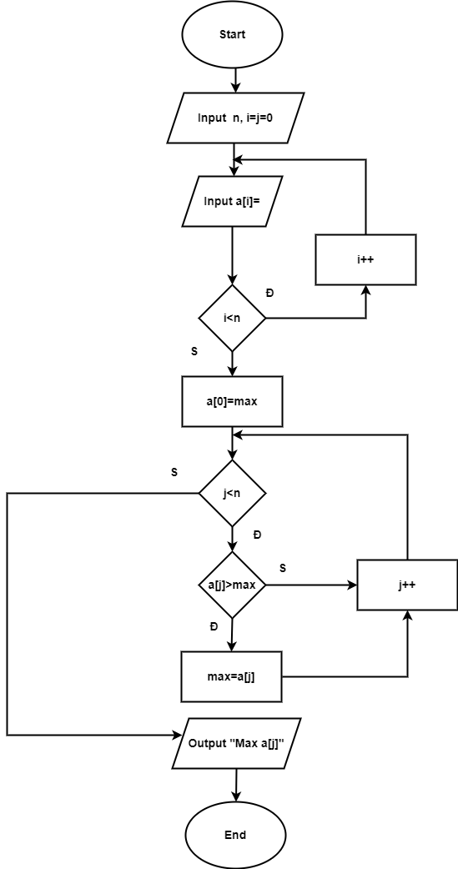

Fseudo-code

Begin

Input n, i=j=0

While (i<n)

Do

Input a[i]

i++

a[0]=max

While(j<n)

Do

IF (a[j]>max) THEN

max=a[j]

j++

Output a[i]

End